**How to change the NR details once the NR receipt is APPROVED BY FM**

**(Enhancement)**

# Contents

1. Existing Flow: 3

2. Proposed Flow: 4

# Existing Flow:

1. Currently, after Passed for Payment Finance Manager (once the NR receipt is APPROVED BY FM), NR receipt uploaded and details cannot be changed or new NR receipt cannot be added, we just have View option in the NR Dashboard.

## Claimant makes their Mileage expenses:

1. When the NR Rule is ON, we allow the claimant to claim mileage expenses which are dated **before** turning ON the NR Rule. Therefore, there will be validation on the date field, which allows the claimant to submit the expenses prior to turning on the NR Rule.
2. When the mileage expenses are dated **after** the date of enabling the NR rule and the claimant can create a mileage expense after submitting the Non-Reimbursable fuel Expense with the fuel receipt. (**Screen 1**)

Screen 1

## NR Dashboard:

1. The Finance Manager Dashboard has the option NR Dashboard in the bottom. **(Screen 2**)

Screen 2

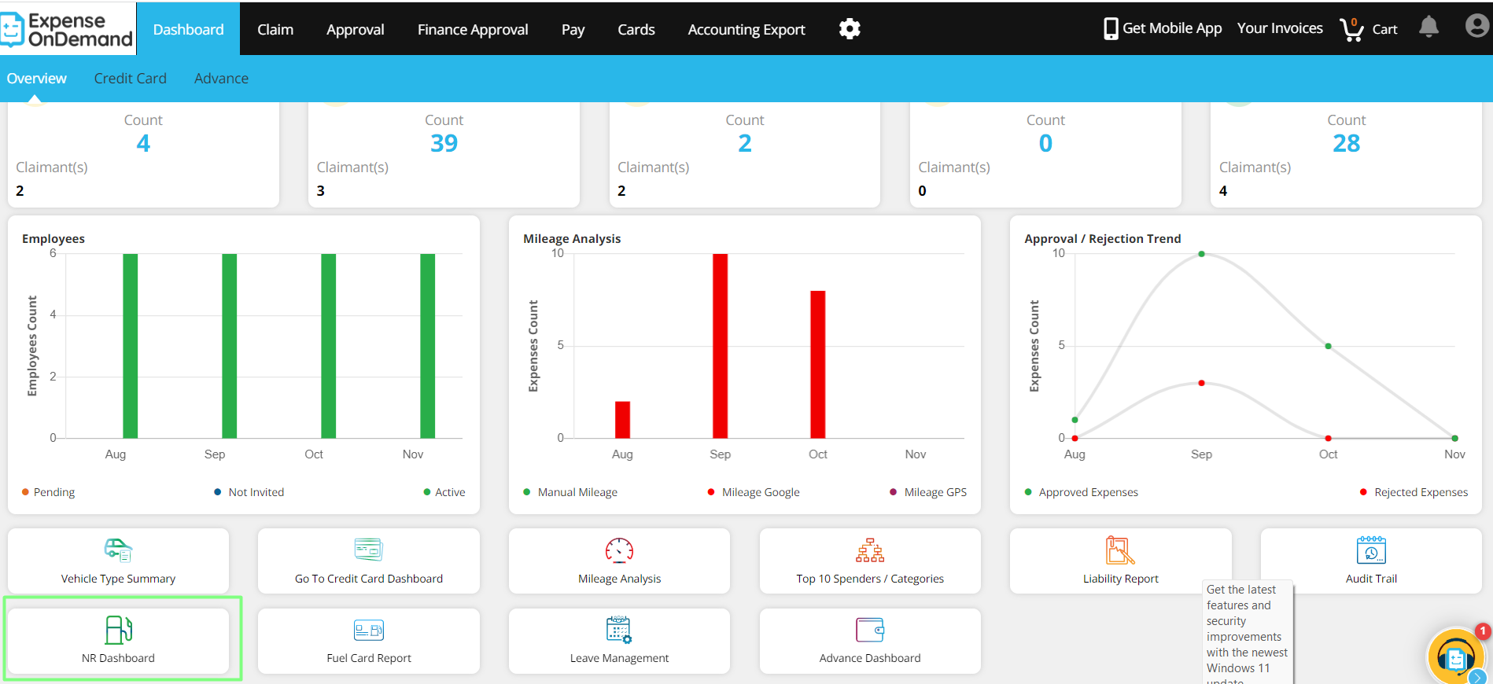

1. Finance Manager when clicks on NR Dashboard card, the NR Dashboard opens. (Screen 3) which has the following fields in the grid with the heading of the screen as “Non-Reimbursable Fuel Compliance by Claimants”:

* Claimant Name
* Compliant – Compliant / Non-Compliant
* **Surplus / Deficit**

Screen 3

When the FM clicks on the “**>**” sign-

1. He will be navigated to the screen with the of the full history of the specific claimant’s Mileage claims and fuel receipt.
2. Only one claimant at a time can be viewed.
3. In the screen below (**Screen 4**) we have displayed that there could be multiple mileage claims linked to a single fuel receipt.

There are several pieces of information here:

1. On the TOP Left corner, there is a <Name of Claimant>, with **COMPLIANT** or **NON-COMPLIANT**. The COMPLIANT

is in Green and NON-COMPLIANT is in RED.

1. In the next line, but on extreme top right we have the “**Cost of Fuel…**”. This is the money value of Fuel; the FM has

Attributed to each mile travelled. This is coming here from the Setup area. This is the amount which determines

how many miles/km the claimant can travel with the cost of fuel (without VAT) they have entered.

1. In the grid below:
2. 1st column displays the **TOTAL receipt Amount** (including the VAT)
3. 2nd column displays the **VAT**.
4. 3rd columns is the “**Miles available**”, which the claimant can drive with this amount. This is a function of the NET COST OF FUEL divided by the Fuel Element amount.
5. 4th column is the date of the Fuel Receipt.
6. 5th column is the **miles travelled** on a particular date. This is coming from the Mileage expense incurred on a particular date.
7. 6th column, is the **UID** is the Unique ID (Number) of this expense item.
8. 7th column is the **COST OF FUEL** in the subscription currency. This is based on the “number of miles travelled” multiplied by the “Fuel Element”.
9. 8th column is the **VAT Claimable** on the COST OF FUEL.
10. 9th column is the running **balance**, i.e., the miles left after every journey plus miles added with every fuelling of the vehicle.
11. 10th column, is the copy of the **receipt**.

Screen 4

1. The FM can only view the Receipt by clicking on the **View** button. (**Screen 5**)
2. The receipt opens in a side panel. The Receipt uploaded by the claimant (Submitted and Approved) with NR category is displayed here. The UIDs linked with the specific Receipt is also displayed. Below that there is a View Map icon, clicking on which the map will open. **FM cannot add any new receipt or make changes in the records. (current limitation)**

Screen 5

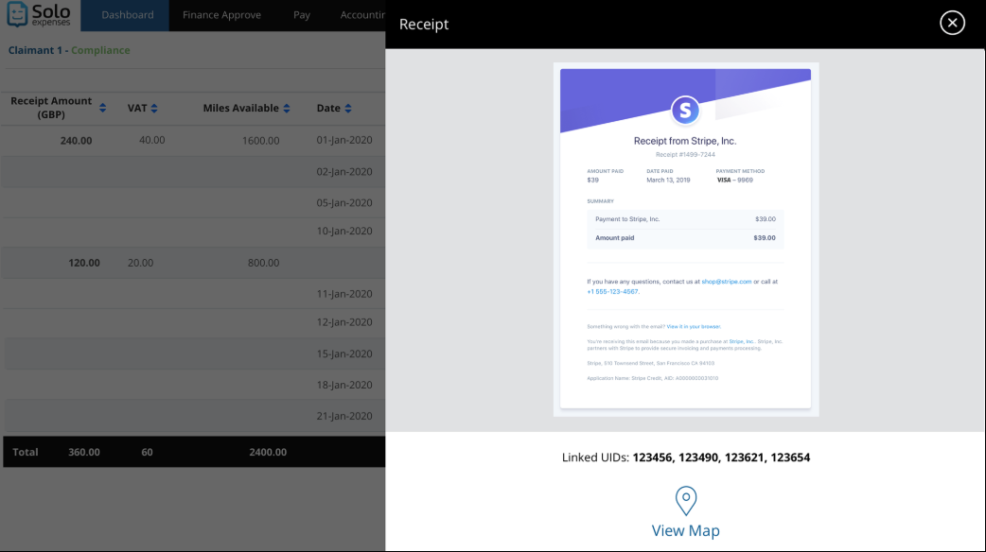

# Proposed Flow:

The flow will remain the same, the only difference will be that now we will be providing Log and Amend link before the Receipt Amount column in the grid. (**Screen 6**)

Screen 6

On clicking **Log** link, a panel named log will open which will display all the changed done for that Receipt. (**Screen 7**)

Screen 7

On clicking **Amend** link, a panel will open to add a new receipt, delete the existing receipt. (**Screen 8**)

Screen 8